**Exploratory Data Analysis (EDA) Report**

By: Team 10 | 1002 AI-Powered Insights Early Internship

Sponser : Excelerate  
Dated: February 23,2025

**EDA (Exploratory Data Analysis) Report**

**TEAM- 10:**

* **Sponsor Company** – Excelerate  
  **Member Name(s)** – Role(s), Responsibilities in Company
* **Tisha Chawlani** - Team Lead, represents team to sponsor, via email and on calls, to minimize communication errors.
* **Mahnoor** - Project Manager, provides guidance and draws out insight from other team members, ensures that the project execution remains on track.
* **Shelly Nagar**- Project Scribe, responsible for taking meeting minutes and distributing notes/assignments. Can assist Team Lead in drafting emails and communication between sponsor and group.
* **Hibah Sindi** - Project Lead, responsible for holding the group accountable for meeting deadlines and ensuring that the project deliverables are being met.
* **Yevate Aditya, Emmanuel Gyan, Stephen Makoshi, Harshvardhan Molleti, Krishna Bandi** - Team Member, contribute to the successful completion of the project by performing assigned tasks, collaborating with other team members, and supporting the overall project goals

# **Task Allocation**

# The **task allocation sheet** documents the division of responsibilities among team members for **Week 1 and Week 2**, ensuring efficient workflow and collaboration.

📂 **Task Allocation Sheet:** [**Google Spreadsheet Link**](https://docs.google.com/spreadsheets/d/1OMHpmu9RiZnPR7AFC_3WLrlm4vjIPdMwiksk0nytwJw/edit?usp=sharing)

### **📌 Week 1: Two Subteams**

🔹 **Research Report Team:** Conducted background research and structured the report.  
🔹 **Data Cleaning & Preprocessing Team:** Focused on refining the dataset for analysis.

### **📌 Week 2: Three Subteams**

🔹 **EDA Report Team:** Compiling exploratory data analysis findings into a structured report.  
🔹 **Data Visualization Team:** Creating insightful charts and visual representations.  
🔹 **EDA Analysis Team:** Conducting in-depth statistical and pattern analysis.🔹 This structured approach ensures **clear task ownership, streamlined execution, and optimized collaboration.**

# **Cleaned Dataset - Week 1**

The **cleaned dataset** used for analysis after preprocessing in **Week 1** is available here:

**Dataset Link:** [**Cleaned Dataset - Week 1**](https://drive.google.com/file/d/1NA7qNDrD3p__3jFQaPvsWqHrCIZrmZdT/view?usp=sharing)

### **Dataset Overview:**

* Processed and refined for **accuracy and consistency**.
* Used in **bivariate analysis, EDA, and data visualization**.
* Serves as the foundation for **Week 2 advanced analysis**

This dataset ensures a **high-quality data foundation** for deriving meaningful insights.

# **Bivariate Analysis**

Bivariate analysis examines the relationship between two variables to identify key trends, correlations, and patterns in **signups, completion rates, and drop-offs**. The complete analysis, including data visualizations and statistical insights, is documented in the following Python files:

📂 **Folder Link:** [**Bivariate Analysis - Python Files**](https://drive.google.com/drive/folders/170fGiwMmwnICINuCT0_ogk8gv-VtZ35c?usp=sharing)

### **Contents of the Folder:**

1️⃣ **Bivariate Analysis - Part 1 & Part 2:** Detailed exploration of signups, completion trends, and demographic insights.  
2️⃣ **Variable Relationship Analysis:** Examines the interdependencies between different variables to uncover deeper insights.

The key findings from these analyses are summarized in this report.

### **Univariate Analysis**

### Univariate analysis helps understand the distribution, central tendency, and dispersion of individual variables. The full analysis is performed in the **EDA & Visualization Python File** and can be accessed here:

📂 **File Link:** [Univariate Analysis Insights](https://docs.google.com/document/d/1MCBBpsRawVtmxR-splBKBW-oOzSiit_i/edit?usp=sharing&ouid=105934941968562617712&rtpof=true&sd=true)

**Contents:**✅ **Summary Statistics:** Mean, median, mode, and standard deviation.  
✅ **Visual Analysis:** Histograms, box plots, and density plots.  
✅ **Outlier Detection:** Identification of extreme values.

**EDA & Data Visualization**

Exploratory Data Analysis (EDA) and data visualization help identify trends, patterns, and anomalies in the dataset. This process involves statistical summaries and graphical insights to understand key metrics like signups, engagement, and demographics.To see the full process and the code structure please refer to the code

📂 **File Link:** [**EDA & Data Visualization - Python File**](https://colab.research.google.com/drive/1AZp9eMnRBXv75O0h4qD1i4D1xVX1I4hx?usp=sharing)

**Contents:**✅ **Comprehensive EDA**: Summary statistics, missing values, and key observations.  
✅ **Visual Insights**: Charts and graphs for distributions, trends, and correlations.

# 

# ***Introduction:***

### **Dataset Overview**

### The dataset used in this analysis contains **8,536 records** and **39 columns**, capturing details about learner signups for various opportunities such as **Internships, Courses, Events, Competitions, and Engagement Activities**. The dataset includes information on:

* **Demographics:** Age, gender, country, and institution details.
* **Opportunity Details:** Category, duration, and engagement metrics.
* **Time-based Data:** Signup date, application date, and participation trends.

The data appears to be sourced from an **educational or career development platform**, tracking user participation in different learning and work-based programs.

The dataset consists of 8,536 entries (rows) and 39 columns, providing a comprehensive set of information related to learners' engagement with various opportunities. Here's an overview of the data:

### **1. Datetime Columns:**

The dataset includes six columns related to dates in datetime64[ns] format:

* learner_signup_datetime: Timestamp of when the learner signed up.
* opportunity_end_date: The end date of the opportunity.
* date_of_birth: Learner's date of birth.
* entry_created_at: The date the entry was created.
* apply_date: Date when the learner applied.
* opportunity_start_date: The start date of the opportunity.

### **2. Personal Information:**

The dataset includes columns with personal information about the learners, including:

* first_name: First name of the learner (with a small number of missing values: 8534 non-null).
* gender: Gender of the learner.
* country: The country the learner is from.
* institution_name: The name of the institution to which the learner belongs.
* current/intended_major: The current or intended major of the learner.
* age: The age of the learner.

### **3. Opportunity Details:**

The dataset provides details about the opportunities, such as:

* opportunity_id: A unique identifier for each opportunity.
* opportunity_name: Name of the opportunity.
* opportunity_category: The category of the opportunity.
* opportunity_duration: The duration of the opportunity in days.
* status_description: Describes the status of the opportunity.
* status_code: Numeric code representing the status.

### **4. Date Breakdown:**

Several columns represent the breakdown of various date-related information into year, month, and day, for the following:

* learner_signup_datetime
* opportunity_end_date
* date_of_birth
* entry_created_at
* apply_date
* opportunity_start_date

### **5. Engagement and Interaction Metrics:**

* engagement_time: The amount of time the learner engaged with the opportunity.
* duration_age_interaction: A measure of the interaction's duration based on age.
* engagement_score: A score representing the learner's engagement level with the opportunity, which is a float64 type.

### **6. Data Quality:**

* The dataset contains no missing values for the majority of columns, except for a minor missing value in the first_name column.
* All columns with numeric data types (int64 and float64) are completely populated, ensuring reliable calculations and analysis.

### **Data Types Summary:**

* **Object:** 9 columns (including categorical and textual information such as opportunity_name, gender, country, etc.).
* **Integer:** 23 columns (including date breakdowns and status-related codes).
* **Datetime:** 6 columns (storing timestamp information for various events).
* **Float64:** 1 column (engagement_score).

## **Descriptive Statistics Overview**

### **1. Datetime Columns:**

* **Learner_signup_datetime:**
  + Min: 2023-01-05 00:00:00
  + Max: 2024-04-09 00:00:00
  + Mean: 2023-09-29 14:49:02
* **Opportunity_end_date:**
  + Min: 2023-03-01 00:00:00
  + Max: 2025-12-24 00:00:00
  + Mean: 2024-05-04 07:07:48
* **Date_of_birth:**
  + Min: 1966-08-08 00:00:00
  + Max: 2011-02-17 00:00:00
  + Mean: 1999-10-02 02:20:31
* **Entry_created_at:**
  + Min: 2024-03-11 00:00:00
  + Max: 2024-03-11 00:00:00
  + Mean: 2024-03-11 00:00:00
* **Apply_date:**
  + Min: 2022-10-05 00:00:00
  + Max: 2024-04-10 00:00:00
  + Mean: 2023-11-24 22:01:24
* **Opportunity_start_date:**
  + Min: 2022-11-03 00:00:00
  + Max: 2024-05-31 00:00:00
  + Mean: 2023-10-26 07:08:39

### **2. Categorical Columns:**

* **Opportunity_Id:**
  + Unique: 23
  + Most Frequent (top): 00000000-0GN2-A0AY-7XK8-C5FZPP
  + Frequency (freq): 1413
* **Opportunity_Name:**
  + Unique: 22
  + Most Frequent (top): Career Essentials: Getting Started with Your P...
  + Frequency (freq): 1413
* **Opportunity_Category:**
  + Unique: 5
  + Most Frequent (top): Internship
  + Frequency (freq): 5414
* **Gender:**
  + Unique: 4
  + Most Frequent (top): Male
  + Frequency (freq): 5006
* **Country:**
  + Unique: 69
  + Most Frequent (top): United States
  + Frequency (freq): 3974
* **Institution_Name:**
  + Unique: 1916
  + Most Frequent (top): Saint Louis University
  + Frequency (freq): 4522
* **Current/Intended_Major:**
  + Unique: 343
  + Most Frequent (top): Information Systems
  + Frequency (freq): 2176
* **Status_Description:**
  + Unique: 8
  + Most Frequent (top): Rejected
  + Frequency (freq): 3563

### **3. Numerical Columns:**

* **Status_Code:**
  + **Mean:** 1052.202437
  + **STD:** 21.652294
* **Age:**
  + **Mean:** 24.89
  + **Min:** 14
  + **Max:** 58
  + **STD:** 4.37
* **Opportunity_Duration:**
  + **Mean:** 191.00 days
  + **Min:** -313.0 days (possible data issue)
  + **Max:** 913.0 days
  + **STD:** 240.32
* **Engagement & Interaction:**
  + **Engagement_Time:**
    - **Mean:** 29.62
    - **Min:** -338.0 (possible data issue)
    - **Max:** 490.0
    - **STD:** 133.68
  + **Duration_Age_Interaction:**
    - **Mean:** 4742.61
    - **Min:** -8138.0 (possible data issue)
    - **Max:** 52041.0
    - **STD:** 6133.76
  + **Engagement_Score:**
    - **Mean:** 92.75
    - **Min**: -221.2 (possible data issue)
    - **Max:** 448.3
    - **STD:** 127.99

### **4. Year, Month, Day Columns:**

For each of the datetime columns, the dataset also includes their year, month, and day breakdowns:

* learner_signup_datetime_year: Mean = 2023.32, Min = 2023, Max = 2024
* opportunity_end_date_year: Mean = 2024.03, Min = 2023, Max = 2025
* date_of_birth_year: Mean = 1999.24, Min = 1966, Max = 2011
* entry_created_at_year: All entries are 2024.
* apply_date_year: Mean = 2023.56, Min = 2022, Max = 2024
* opportunity_start_date_year: Mean = 2023.63, Min = 2022, Max = 2024

### **Key Observations:**

* There are some negative values in opportunity_duration, engagement_time, duration_age_interaction, and engagement_score, which likely indicate data issues.
* Most frequent categories:
  + Opportunity category: Internship
  + Status description: Rejected
  + Gender: Male
  + Country: United States

### **Analysis Goals**

The primary objective of this analysis is to understand **trends in signups and engagement** across different opportunity categories. This is crucial for:

* **Identifying High-Interest Areas:** Determining which opportunities attract the most users.
* **Improving User Retention:** Analyzing engagement scores to refine program offerings.
* **Optimizing Business Strategy:** Using data-driven insights to enhance marketing, outreach, and resource allocation.

Understanding these trends can help improve **platform growth, user experience, and overall business success** by aligning opportunities with user preferences.

***Signup Trends:***

## **Growth: Opportunity Category vs. Signup Count**

*This analysis examines the distribution of signups across different opportunity categories, highlighting learner preferences and engagement levels.*

### **Extracted Chart:**

🔹 **Signups per Opportunity Category**

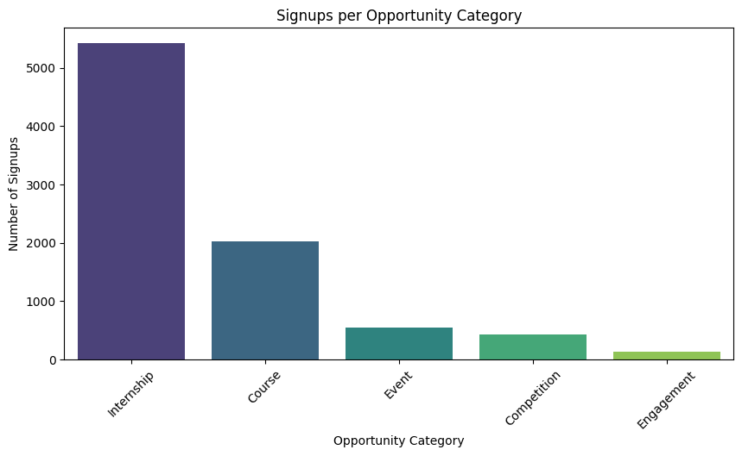

### **Key Insights:**

**1. Internships are the most Preferred Opportunities**

* **Around 5,414 signups** learners prioritize hands-on experience on **real-world problems, industry exposure, and skill application**.
* This highlights a strong demand for **practical, hands-on learning over traditional theoretical courses**.

**2. Courses Are the Second Most Popular Category**

* **2,023 signups** show strong interest in **structured learning programs**.
* Learners prefer **self-paced education** that supports **academic and professional development**.

**3. Low Engagement in Events, Competitions, and Engagement Activities**

* Participation is significantly lower in **Events (545), Competitions (425), and Engagement Activities (129)** due to limited visibility, unclear career benefits, or lack of alignment with learner goals.

### **Recommendations:**

**1. Boost Engagement in Less Popular Categories**🔹 **Events & Competitions:** Highlight networking, exposure, and resume-building benefits.  
🔹 **Engagement Activities:** Introduce **certificates, rewards, or internship-linked incentives** to drive participation.

**2. Enhance Marketing & Outreach Strategies**🔹 Run **surveys** to understand learner preferences across categories.  
🔹 Analyze **drop-off rates** to see if users disengage after signing up.  
🔹 **Promote** **low-signup** programs with better **visibility.**

## **Growth: Application & Signup Trends Over Time**

*This analysis will help examine the long-term trends in applications and signups, highlighting growth patterns, peak engagement periods, and fluctuations over time.*

### **Extracted Chart:**

🔹 **Signups vs. Applications Over Time**

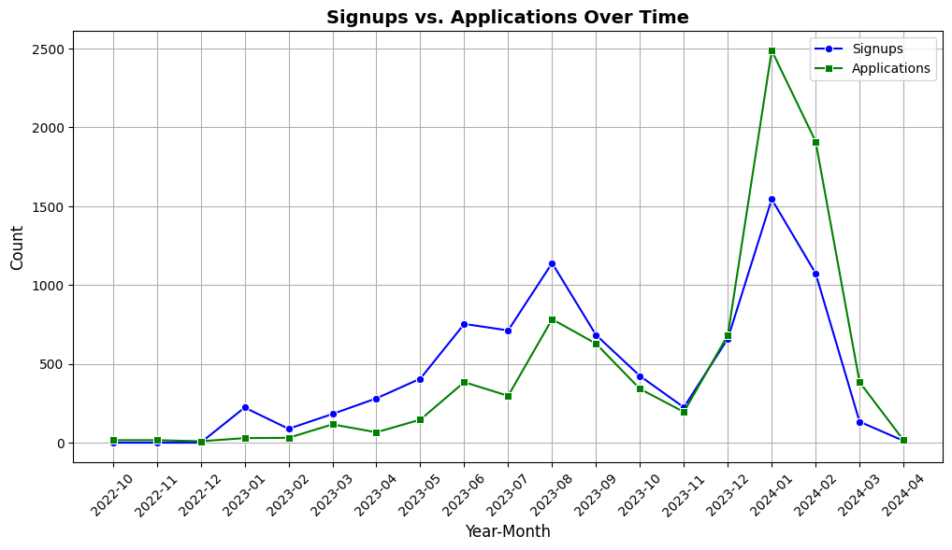

### **Key Observations & Trends:**

**1. Gradual Growth in Signups & Applications**

* **There were no signups from Oct 2022 to Dec 2022**, while applications remained low (**16, 16, and 9, respectively**).
* **Jan 2023 marked the start of signups (223 signups)**, indicating **growing interest in opportunities**.

**2. Peak Engagement in Early 2024**

* **January 2024 saw the highest engagement spike**:
  + **2,487 applications** and **1,544 signups**, suggesting **effective outreach efforts** and **attractive opportunities**.
* **February 2024 maintained strong engagement** (**1,910 applications, 1,074 signups**).

**3. Fluctuations & Decline in Recent Months**

* **March 2024 saw a sharp decline** (**133 signups, 384 applications**).
* **April 2024 (so far) has extremely low engagement** (**12 signups, 16 applications**).
* **Possible reasons:**
  + **Seasonal variations affecting engagement**.
  + **Fewer attractive opportunities are available**.
  + **Reduced marketing or outreach effectiveness**.

**4. Signup-to-Application Ratio Trends**

* **Before June 2023, applications exceeded signups**, suggesting **hesitation in commitment after applying**.
* **From June 2023 onward, the gap narrowed**, and in some months, **signups surpassed applications (e.g., Dec 2023)**.
* **This indicates stronger conversion efforts and better-aligned opportunities**.

### **Key Takeaways & Recommendations:**

**1. Investigate Drop in March-April 2024**

* Identify **seasonal, structural, or outreach-related factors** behind the decline.
* Adjust marketing strategies to **maintain engagement in these months**.

**2. Capitalize on Peak Engagement Periods (Jan-Feb 2024)**

* Since these months **show strong traction**, optimize campaigns around them.
* Plan **major outreach events, promotions, and opportunity launches** during this time.

**3. Improve Conversion from Application to Signup**

* Implement strategies to **encourage faster signups**:
* **Personalized follow-ups**.
* **Email reminders with deadline urgency**.
* **Automated engagement nudges to applicants**.

**4. Analyze Seasonal Patterns to Improve Retention**

* Identify **causes of engagement fluctuations** throughout the year.
* Develop a **data-driven outreach calendar** to optimize participation at the right times.

## 

## **Spikes/Drops: Opportunity Category-wise Signups & Drop-off Rate**

*This analysis highlights significant spikes and drops in signups across different opportunity categories while also analyzing drop-off rates. It helps identify which categories attract the most learners and where disengagement occurs the most.*

### **Extracted Charts:**

🔹 **Signups by Opportunity Category**🔹 **Drop-off Rate by Opportunity Category**

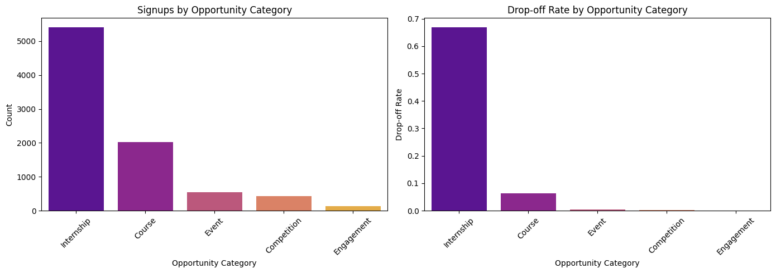

### **Key Insights:**

**1. Internships Have the Highest Signups but Also the Highest Drop-Off Rate**

* **5,414 signups** make internships the **most popular opportunity type**.
* However, they also have the **highest drop-off rate (66.9%)**, indicating **engagement and retention challenges**.
* **Possible reasons for high drop-offs:**
  + Long durations lead to **time commitment issues**.
  + Workload **mismatch with learner expectations**.
  + **Lack of structured support or mentorship**.

**2. Courses Have Moderate Signups and a Low Drop-Off Rate**

* **2,023 signups**, making courses the **second most preferred category**.
* **The drop-off rate is only 6.37%**, meaning courses have a **higher retention rate than internships**.
* The **structured nature of courses** makes them more manageable and engaging for learners.

**3. Events and Competitions Have Minimal Drop-Offs**

* **Events (545 signups, 0.37% drop-off)** and **Competitions (425 signups, 0.23% drop-off)** show **high retention rates**.
* These opportunities are **short-term, engaging, and require minimal long-term commitment**, making them **easy to complete**.

**4. Engagement-Based Opportunities Have 0% Drop-Off**

* **Engagement activities (129 signups) have a 100% retention rate**, meaning all participants completed them.
* **Possible reasons for high retention:**
  + **Interactive and community-driven learning experiences**.
  + **Mentorship and networking aspects** that keep learners engaged.

## **Actionable Recommendations:**

**1. Improve Internship Retention Strategies**

* Introduce **midway check-ins, milestone-based rewards, and flexible structures** to maintain engagement.
* Implement **mentorship programs** to provide ongoing support.
* Match learners with **better-suited opportunities** to **reduce expectation mismatches**.

**2. Optimize Course Engagement**

* Add **interactive elements like gamification, discussion forums, and live Q&A sessions** to enhance participation.
* Provide **personalized learning paths based on learner engagement and performance levels**.

**3. Leverage Short-Term Opportunities for Engagement**

* Use **Competitions and Events as onboarding tools** for longer opportunities.
* Encourage participants who complete events to **transition into internships or courses**.

**4. Expand Engagement-Based Learning**

* Scale **mentorship and networking-driven programs**, as they have **proven to maintain 100% retention**.
* Introduce **peer learning, real-world projects, and networking sessions** to improve engagement across other categories.

## 

## **Additional Insights: Signup Growth, Seasonality, and Spikes/Drops**

*This section analyzes overall signup trends, identifying key growth periods, seasonal patterns, and fluctuations in engagement.*

### **Extracted Charts:**

🔹 **Signup Growth Chart (Monthly Signups Over Time)**🔹 **Signup Seasonality Heatmap**🔹 **Spikes and Drops in Signup Trends**

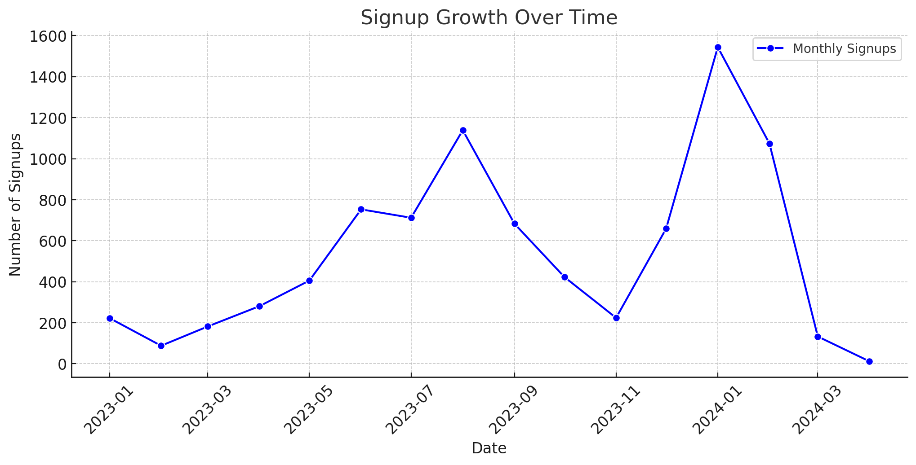

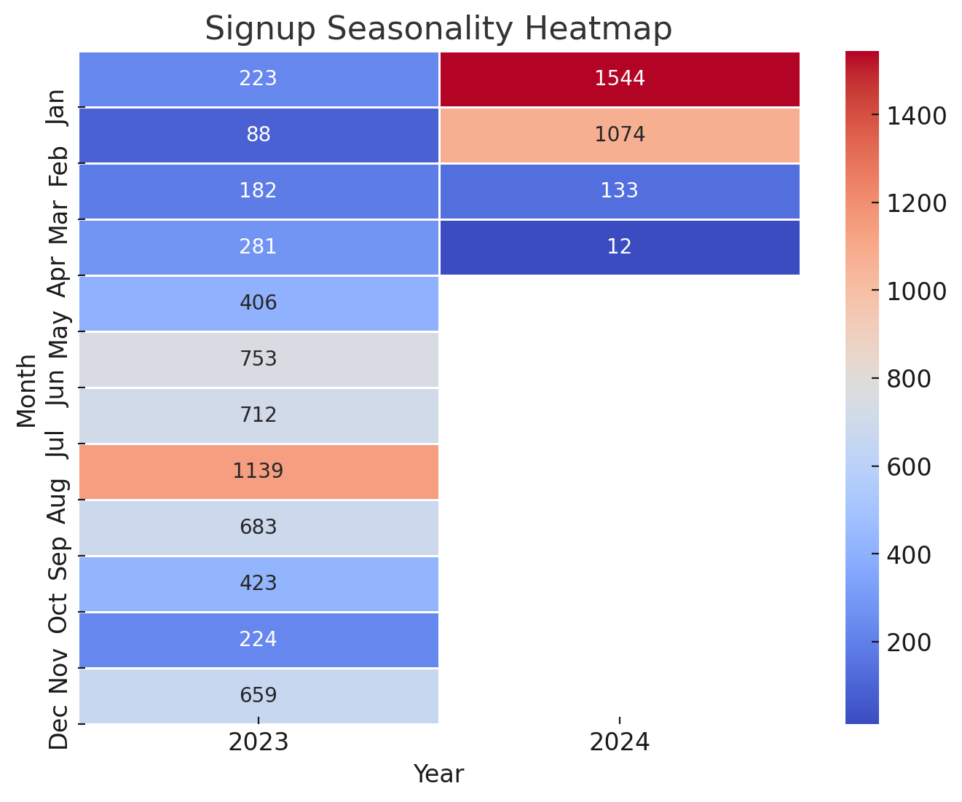

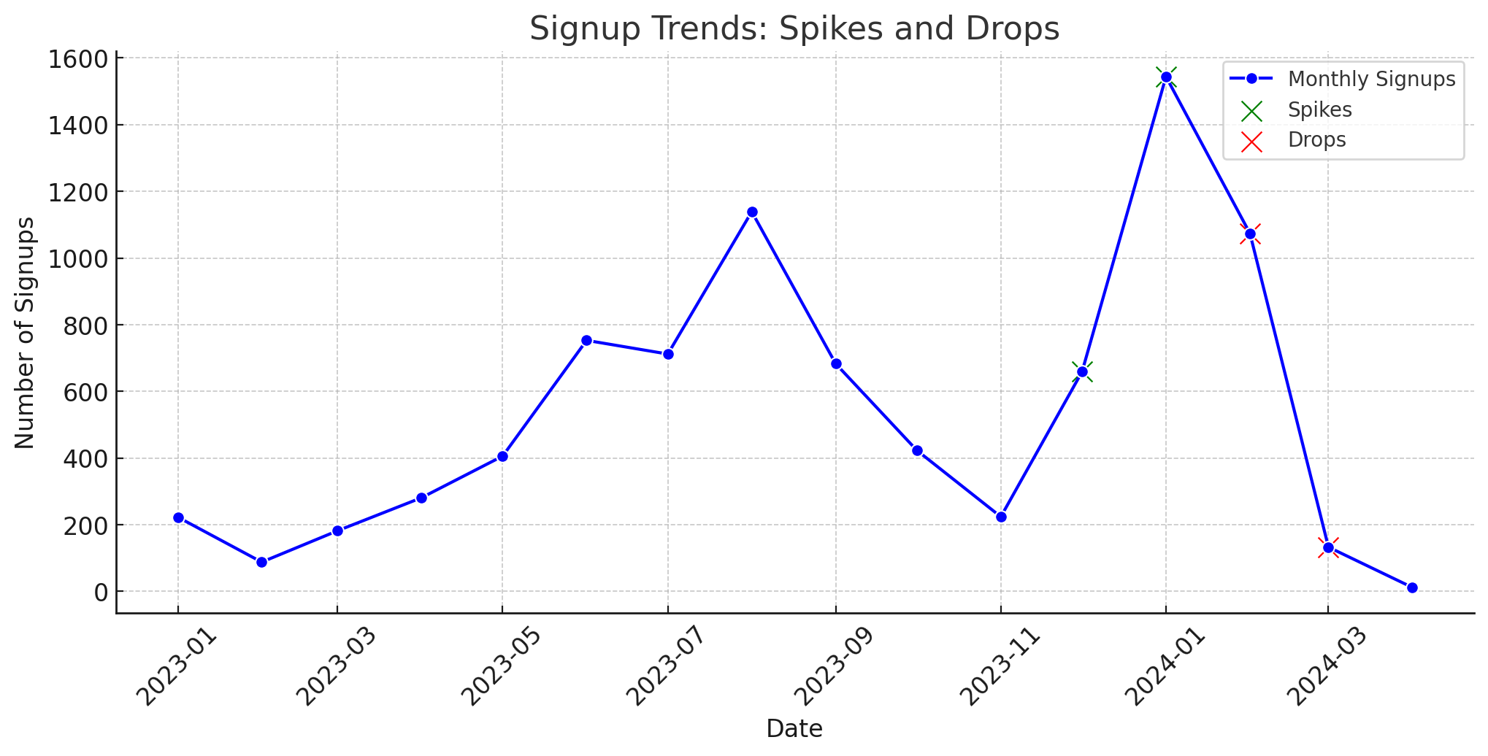

### **Key Observations:**

**1. Significant Growth Periods**

* **August 2023 (1,139 signups) and January 2024 (1,544 signups) saw the highest growth**.
* A **steady increase until mid-2023** led to a peak in **early 2024**.

**2. Major Drop in April 2024**

* **April 2024 saw an extreme decline (only 12 signups)**.
* Possible reasons include **seasonal trends, fewer opportunities, or reduced outreach efforts**.

**3. Seasonal Trends (Signup Heatmap Analysis)**

* **Peak Signup Months:** **January and August consistently show high engagement**.
* **Low Activity Months:** **April and May see the lowest signup numbers**.
* **Pattern Suggestion:** Learner interest rises **at the beginning and middle of the year**.

**4. Spikes and Drops in Signup Trends**

* **Major Spikes:**
  + **December 2023 (+435 signups)**
  + **January 2024 (+885 signups) – Highest increase**
* **Major Drops:**
  + **February 2024 (-470 signups)**
  + **March 2024 (-941 signups) – Largest decline**

### **Context:**

* The **December–January spike** suggests **successful holiday campaigns or new-year enrollments**.
* The **February–March decline** may be influenced by **seasonality effects or marketing shifts**.

**Key Takeaways & Recommendations:**

**1. Investigate Causes of April 2024 Drop**

* Analyze **seasonal trends, opportunity availability, and marketing effectiveness**.
* Introduce **new engagement initiatives to sustain participation**.

**2. Capitalize on Peak Signup Periods (January & August)**

* Optimize **outreach and campaign efforts** around high-traffic months.
* Plan **promotional offers, webinars, and onboarding sessions** to boost engagement.

**3. Address Spikes and Drops Strategically**

* Study **what worked well in peak months (December–January) and replicate success factors**.
* Develop **re-engagement strategies for post-spike drop-offs** (e.g., reminders, community engagement).

**4. Optimize Seasonal Engagement Strategies**

* Use a **data-driven marketing calendar** to align campaigns with **high- and low-engagement periods**.
* Enhance **targeted promotions during slow months** to prevent participation gaps.

# ***Completion Trends:***

## **Stability: Opportunity Category vs. Average Opportunity Duration**

### *This analysis examines how the duration of different opportunity categories varies, highlighting the time commitment required for each type of program.*

### 

### **Extracted Chart:**

### 🔹 **Average Opportunity Duration by Category**

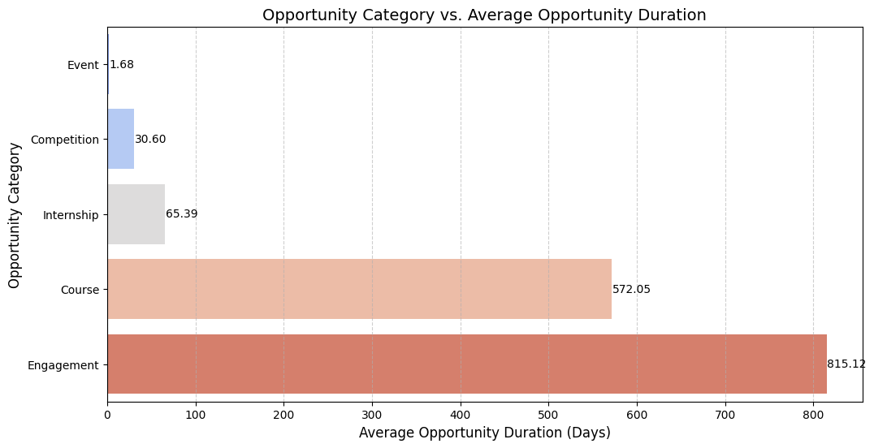

### **Key Observations:**

**1. Events Have the Shortest Average Duration (~1.68 Days)**

* Designed for **networking, knowledge sharing, or skill demonstration**.
* Short duration **attracts quick participation but may limit deep engagement**.

**2. Competitions Last Around 30.6 Days**

* Typically structured with **phases such as registration, participation, and final evaluation**.
* Participants require **moderate time commitment** but may disengage if competition difficulty is too high.

**3. Internships Have a Moderate Duration (~65.39 Days)**

* Strikes a **balance between learning and commitment**.
* Structured **for skill development and real-world application**.

**4. Courses Require Long-Term Commitment (572.05 Days)**

* Demands **sustained engagement**, which can lead to **higher drop-off rates**.
* Without **periodic milestones or incentives**, learners may struggle to complete.

**5. Engagement Programs Have the Longest Duration (~815.12 Days)**

* Typically **continuous or ongoing participation** (e.g., mentorship, networking, professional development).
* Requires **structured support** to maintain engagement over extended periods.

### 

### **Insights & Implications:**

1. **Shorter Durations (Events & Competitions):**

* **Quick participation but lower long-term retention.**
* Participants may **not gain deep learning outcomes**, limiting conversion into other opportunities.

1. **Medium Duration (Internships):**

* **Optimal balance between engagement and commitment.**
* Provides **structured learning with a defined endpoint**, improving completion rates.

1. **Longer Durations (Courses & Engagements):**

* **Higher commitment required**, increasing the risk of **drop-offs**.
* Requires **continuous motivation, structured checkpoints, and engagement strategies**.

### 

### **Strategic Recommendations:**

**1. Improve Retention for Long-Duration Opportunities**

* Introduce **progress tracking, mentorship, and gamification** to maintain engagement.
* Offer **micro-certifications or milestone-based rewards** to keep learners motivated.

**2. Make Courses More Flexible & Interactive**

* Implement **modular learning paths** that allow self-paced progress.
* Add **live sessions, discussion forums, and interactive elements** to improve participation.

**3. Boost Short-Term Engagement Impact**

* Convert event and competition participants into **long-term users** by offering follow-up opportunities.
* Promote **certifications, job referrals, or extended learning options post-event** to encourage continued participation.

## 

## **Stability: Opportunity Duration vs. Completion Rate**

*This analysis examines how the duration of an opportunity impacts its completion rate. Shorter opportunities tend to have higher completion rates, while longer ones often experience drop-offs.*

### 

### **Extracted Charts:**

🔹 **Line Plot: Opportunity Duration vs. Completion Rate**

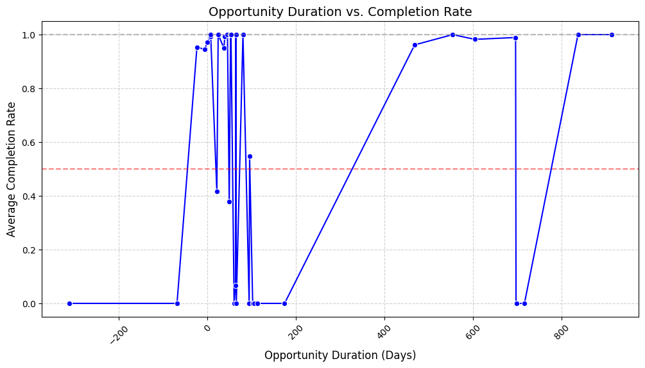

🔹 **Scatter Plot: Opportunity Duration vs. Completion Rate**

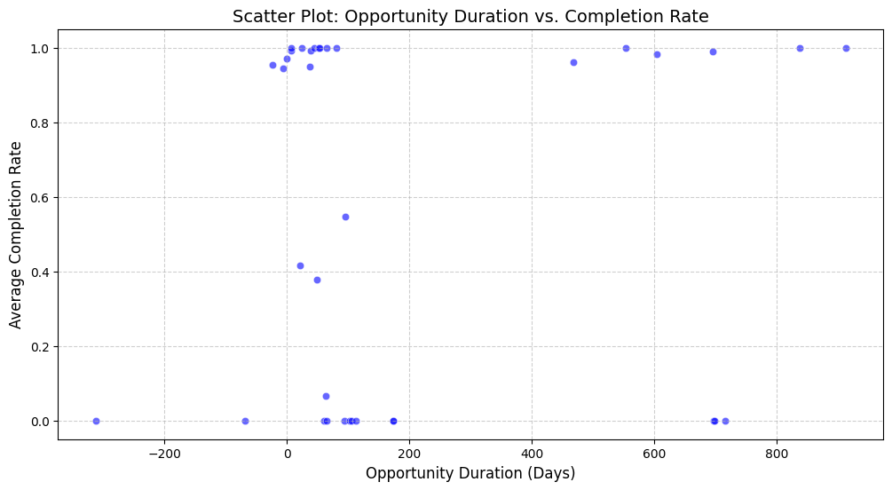

### **Key Observations:**

**1. Shorter-Duration Opportunities Have Higher Completion Rates**

* **Opportunities lasting 0 to 7 days** have a completion rate **above 94%**, with some reaching **100%**.
* **Examples:**
  + **0 days → 97.1% completion**
  + **7 days → 100% completion**
* **Short commitments increase the likelihood of successful completion.**

**2. Mid-Duration Opportunities Show Mixed Trends**

* Opportunities lasting **21 to 60 days** show **fluctuations in completion rates**.
* **Examples:**
  + **45 days → 100% completion**
  + **49 days → 37.8% completion**
  + **60 days → 0% completion**
* **Engagement strategies play a critical role in mid-term program success.**

**3. Very Long-Duration Opportunities (>100 Days) Face Severe Drop-Offs**

* Many **opportunities over 100 days show 0% completion**, suggesting **difficulty in retaining learners**.
* **However, some long-term programs succeed, highlighting the importance of structured support:**
  + **468 days → 96.2% completion**
  + **604 days → 98.9% completion**

**4. Negative Opportunity Duration – Possible Data Issue**

* Some opportunities have **negative durations (e.g., -313, -69 days) with 0% completion**.
* **Possible cause:** Data entry errors or incorrect date calculations.
* **Action:** Investigate these cases to ensure **data accuracy**.

### **Strategic Recommendations:**

### **1. Optimize Shorter Opportunities for Maximum Engagement**

### Expand opportunities **with <7 days duration**, as they have **near-perfect completion rates**.

### Design **micro-learning modules** that fit short-duration formats.

**2. Enhance Engagement for Mid-Term Programs**

* Identify **successful 21-60 day opportunities** and apply their best practices to others.
* Implement **progress tracking, mentorship, and periodic check-ins** to improve retention.

**3. Improve Support for Long-Term Opportunities**

* Introduce **structured milestone tracking, mentoring, and gamification**.
* Offer **incentives, certifications, or career benefits** to maintain engagement in programs **>100 days**.

**4. Fix Data Inconsistencies**

* Investigate and **clean negative-duration records** to prevent misleading insights.
* Improve **data validation checks** for future analyses.

## 

## **Stability: Completion Rates Across Different Opportunity Types**

*This analysis examines how completion rates vary across different types of opportunities. Some formats, such as engagement activities and events, retain learners better, while others, like internships, face high dropout rates.*

### **Extracted Chart:**

🔹 **Completion Rate Across Opportunity Categories**

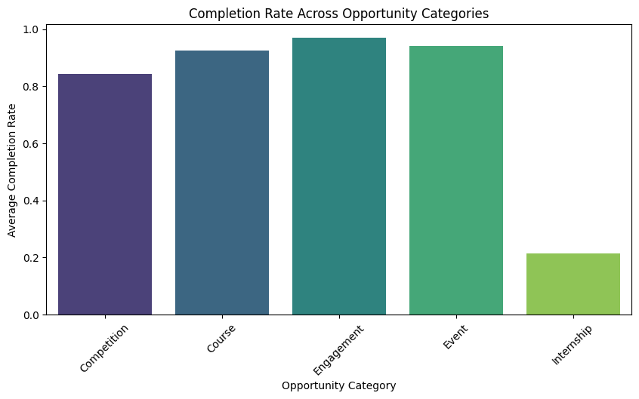

### 

### **Key Observations:**

**1. Engagement, Events, and Courses Have the Highest Completion Rates**

* **Engagement-based opportunities (96.9%)** show the **highest completion rate**, suggesting **interactive and community-driven activities** improve retention.
* **Events (94.1%) and Courses (92.5%)** also maintain **high retention**, indicating structured programs with **short-term commitments** help learners complete them.

**2. Competitions Show Moderate Completion Rates (84.2%)**

* Competitions have **strong completion rates** but lower than courses and events.
* **Possible reasons:**
  + Some learners **lose interest if they feel they cannot win**.
  + **Participants may register but not fully engage**, leading to lower completion.

**3. Internships Have the Lowest Completion Rate (21.5%)**

* **Longer commitments** contribute to **higher dropout rates**.
* **Possible reasons for low completion:**
  + **Mismatch between expectations and reality**.
  + **Time constraints** from academic or personal obligations.
  + **Lack of structured mentorship and support**.

### 

### **Strategic Recommendations:**

**1. Leverage Engagement-Based Strategies**

* **Interactive and community-driven activities retain participants better**.
* Integrate **mentorship, gamification, and peer collaboration** into longer opportunities.

**2. Optimize Internship Programs to Reduce Drop-Offs**

* Set **clear expectations upfront** to prevent mismatches.
* Introduce **structured mentorship programs** to provide ongoing support.
* Ensure **flexibility in schedules** to accommodate academic and personal commitments.

**3. Support Competition Participants**

* Implement **progress tracking and milestone-based rewards**.
* Provide **mentorship or motivational incentives** to sustain engagement.

**4. Expand Event-Based Learning**

* Since events show **high retention**, use them as **onboarding experiences for longer programs**.

## 

## **Time Variations in Completion Rates**

*This section analyzes fluctuations in completion rates over time and examines variations in completion times using box plots. Understanding these trends helps identify engagement patterns, seasonal shifts, and potential data anomalies.*

### 

### **Extracted Charts:**

🔹 **Completion Rate Trends Over Time**

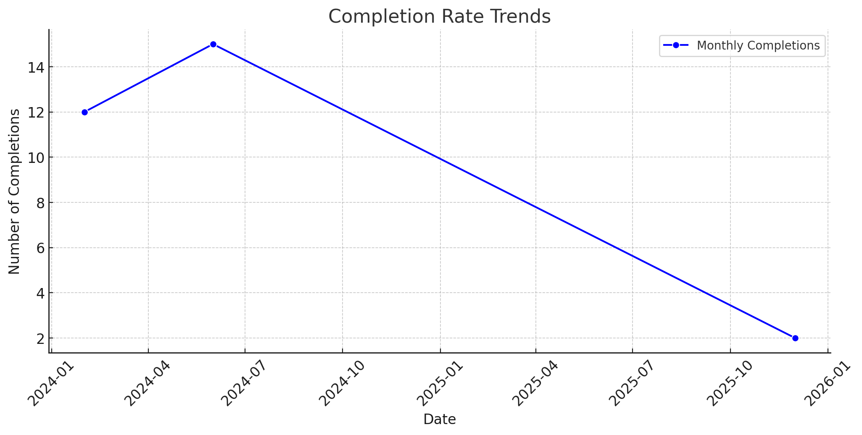

🔹 **Completion Time Variations (Box Plot)**

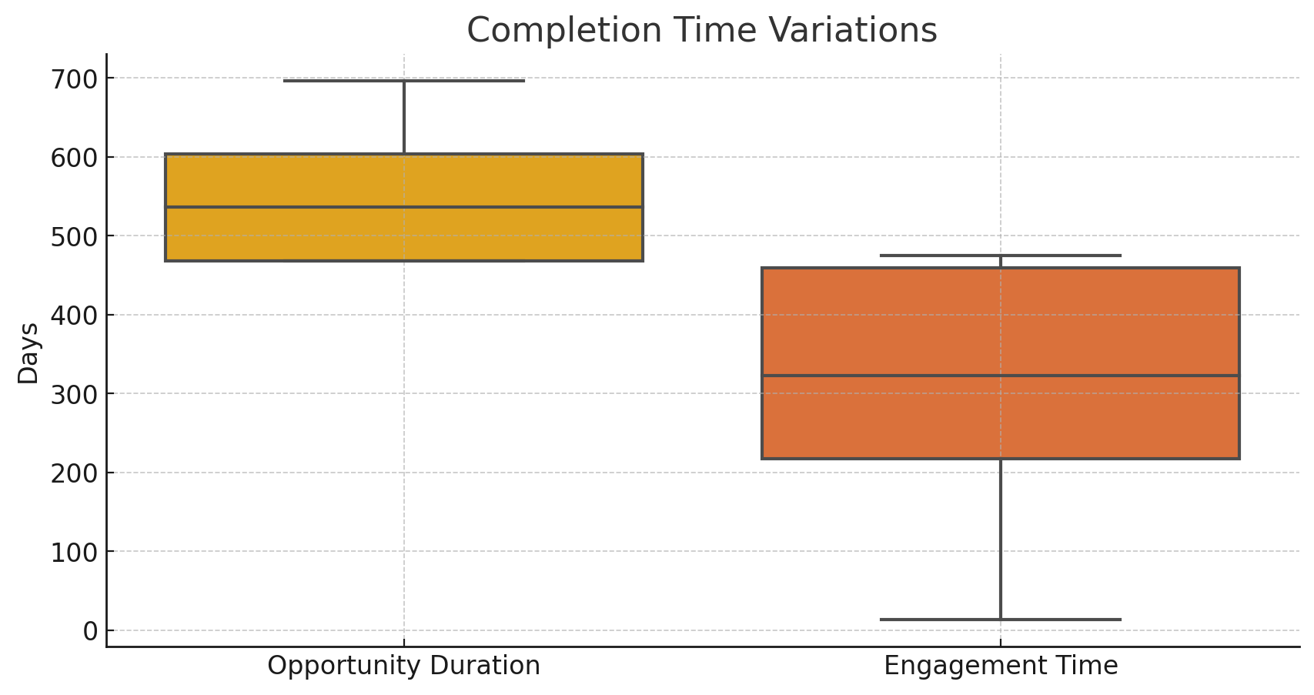

### 

### **Key Observations:**

**1. Growth in Completions in Early 2024**

* A **notable increase in completions was observed in January 2024**, suggesting **higher engagement during this period**.
* Mid-year fluctuations indicate **seasonal engagement variations**, potentially driven by academic or work cycles.

**2. Decline in Completion Rates During March 2024**

* A **significant drop in completions during March 2024** suggests possible disengagement or program-related challenges.
* **Potential reasons for the decline:**
  + Fewer attractive opportunities available.
  + Drop in learner motivation or external factors affecting participation.
  + Structural issues in programs leading to higher drop-offs.

**3. High Variability in Completion Times**

* **Box plot analysis highlights significant fluctuations in engagement time and opportunity duration.**
* **Median values:**
  + **Median opportunity duration: ~468 days**.
  + **Median engagement time: ~206 days**.
* **Outliers:**
  + Some completions took **exceptionally long**, which may indicate **extended programs, delays, or external factors impacting completion time**.
  + **Negative engagement times suggest potential data inconsistencies**, which require further investigation.

### **Strategic Recommendations:**

**1. Address Seasonal Fluctuations in Completion Rates**

* Analyze **learner behavior patterns** to predict high and low engagement periods.
* Develop **seasonal marketing strategies** to maintain completion rates during drop periods.

**2. Investigate March 2024 Drop-Off & Optimize Retention**

* Conduct a **survey or feedback analysis** to identify why learners disengaged.
* Implement **re-engagement strategies**, such as **mentorship, reminders, and incentives**, to encourage completions.

**3. Improve Completion Time Consistency**

* Introduce **structured milestone tracking** to help learners stay on pace.
* Reduce **long-duration engagement issues** by offering **modular course structures** with checkpoints.

**4. Resolve Data Inconsistencies**

* Investigate and **clean negative-duration records** to ensure data accuracy.
* Implement **data validation checks** to prevent future anomalies.

# ***Patterns and Correlations:***

## **Signup vs. Completion: Engagement Score vs. Completion Rate**

*This analysis examines how engagement levels impact completion rates. Higher engagement scores are strongly associated with a higher likelihood of completing an opportunity.*

### 

### **Extracted Chart:**

🔹 **Average Engagement Score by Completion Status**

### 

### **Key Findings:**

**1. Higher Engagement Scores Lead to Higher Completion Rates**

* Learners who **completed their opportunities** had an **average engagement score of 158.12**.
* Those who **did not complete** had a significantly lower **engagement score of 34.27**.
* **This correlation highlights the importance of sustained participation and active engagement.**

**2. Engagement Score Reflects Sustained Participation**

* Engagement score is influenced by **opportunity duration, learner age, and time spent interacting with the opportunity**.
* Learners with **higher engagement scores are significantly more likely to complete** their programs.

**3. The Large Gap Between Engaged and Disengaged Learners Highlights Drop-Off Risks**

* The sharp difference in engagement scores suggests **early disengagement is a strong predictor of drop-offs**.
* Identifying **low-engagement users early can help prevent non-completions**.

### **Actionable Insights & Recommendations:**

**1. Monitor Engagement Scores Early**

* Use **real-time engagement tracking** to detect learners who are at risk of dropping out.
* Identify **low-engagement users** and intervene before they disengage completely.

**2. Implement Targeted Interventions for Low-Engagement Learners**

* Introduce **personalized nudges, reminders, or check-ins** to keep learners engaged.
* Offer **mentorship programs** for learners struggling with longer-duration opportunities.

**3. Further Analysis on Engagement Factors**

* Explore which specific factors (e.g., **duration, activity level, participation frequency**) contribute most to completions.
* Compare **different opportunity types (e.g., internships vs. competitions)** to assess the most effective engagement strategies.

## **Signup vs. Completion: Correlation Matrix Analysis**

*This correlation analysis examines relationships between key engagement metrics, including opportunity duration, engagement scores, completion rates, and drop-offs. The findings help identify factors influencing program success and participant retention.*

### 

### **Extracted Chart:**

🔹 **Correlation Heatmap Between Key Engagement Metrics**

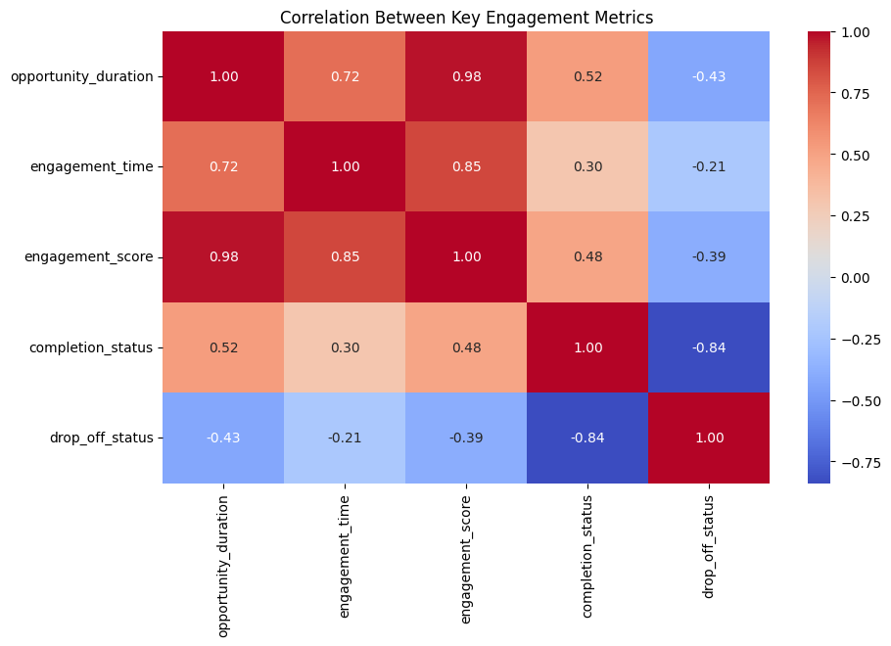

### 

### **Key Insights:**

**1. Strong Positive Correlation Between Opportunity Duration & Engagement Metrics**

* **Opportunity Duration & Engagement Time (0.718):** Longer opportunities lead to **higher engagement levels**.
* **Opportunity Duration & Engagement Score (0.976):** The near-perfect correlation suggests that **longer durations significantly increase engagement scores**, indicating **sustained participation**.

**2. Completion Status is Positively Correlated with Opportunity Duration & Engagement**

* **Completion Status & Opportunity Duration (0.520):** Learners in **longer opportunities** are **more likely to complete**, possibly due to structured programs and greater commitment.
* **Completion Status & Engagement Score (0.483):** **Higher engagement scores lead to higher completion rates**, emphasizing **active participation as a key factor in program success**.

**3. Drop-Off Status is Negatively Correlated with Key Metrics**

* **Drop-Off Status & Completion Status (-0.838):** **Higher drop-off rates reduce completion rates**, as expected.
* **Drop-Off Status & Opportunity Duration (-0.428):** **Short-duration programs have higher drop-offs**, suggesting **challenges in sustaining engagement**.
* **Drop-Off Status & Engagement Score (-0.388):** Lower engagement scores correlate with **higher drop-offs**, reinforcing the need for **interactive elements and continuous learner support**.

### **Key Takeaways & Recommendations:**

**1. Encourage Longer-Duration Programs to Boost Engagement & Completion Rates**

* Since **longer opportunities lead to higher engagement and retention**, design programs that promote **continuous participation**.
* Structure **modular learning pathways** with **checkpoints** to keep participants engaged.

**2. Improve Engagement to Reduce Drop-Offs**

* Introduce **interactive elements, mentorship, and gamification** to maintain motivation.
* Use **progress tracking tools and personalized feedback** to enhance engagement.

**3. Monitor Shorter-Duration Programs for High Drop-Offs**

* Identify why drop-offs are higher in short programs—whether due to **lack of engagement, unclear expectations, or insufficient support**.
* Experiment with **micro-engagement strategies** such as **short tasks, incentives, and real-time nudges**.

**4. Implement Personalized Engagement Tracking**

* Use **real-time monitoring** to intervene early when engagement drops.
* Deploy **automated reminders, peer engagement features, and AI-driven recommendations** to re-engage inactive participants.

## **Demographics: Completion Trends Across Different Age Groups**

*This analysis examines how completion rates vary across different age groups, identifying key trends and engagement strategies for each demographic.*

### 

### **Extracted Chart:**

🔹 **Completion Rate by Age Group**

## 

### 

### **Key Observations & Trends:**

**1. Higher Completion Rates Among Teenagers and Older Participants (50+)**

* **Teenagers (≤19) have a high completion rate (68.8%)**, significantly outperforming young adults.
* **Older participants (50+) have the highest completion rate (83.3%)**, suggesting they are **highly goal-oriented and motivated**.

**2. Lower Completion Rates Among Participants in Their 20s and 30s**

* **Early 20s (45.9%) and Mid 20s (45.7%)** have the lowest completion rates.
* **Possible reasons:**
  + **Academic pressures** (college/university commitments).
  + **Job-seeking activities** reducing time for learning.
  + **Personal obligations** leading to disengagement.
* **Participants in their 30s (46.8%)** perform slightly better but still struggle compared to younger and older learners.

**3. Moderate Completion Rates in the 40s Age Group**

* **Participants in their 40s (51.7%)** have a **higher completion rate than those in their 20s and 30s**.
* **Possible reason:** A stronger focus on **career growth, upskilling, and structured learning**.

### **Key Takeaways & Recommendations:**

**1. Support Young Adults (20s & 30s) to Improve Retention**

* Introduce **flexible schedules, mentorship programs, and incentives** to accommodate their commitments.
* Offer **shorter, self-paced programs** to fit their schedules.

**2. Leverage High Engagement Among Teenagers**

* Teenagers are highly committed—**they should be a priority target group for internships and training programs**.
* Promote **early career programs** that provide **structured skill development**.

**3. Encourage Older Participants (40+) with Advanced Learning Opportunities**

* Older learners (40-50+) show **high motivation**, so offering **advanced-level training, leadership roles, and certifications** can increase engagement.
* Design **career transition programs** to help them apply their learning effectively.

**4. Investigate Drop-Off Reasons Further**

* Conduct **surveys or focus groups** to understand why young adults (20s, 30s) struggle with completion.
* Improve **onboarding, engagement strategies, and structured learning pathways** for these groups.

# 

# **Demographics Analysis: Completion Trends Across Different Genders**

*This analysis examines how completion rates vary across different gender groups, providing insights into engagement levels and inclusivity in opportunities.*

### 

### **Extracted Chart:**

**Completion Rate Across Gender Groups**

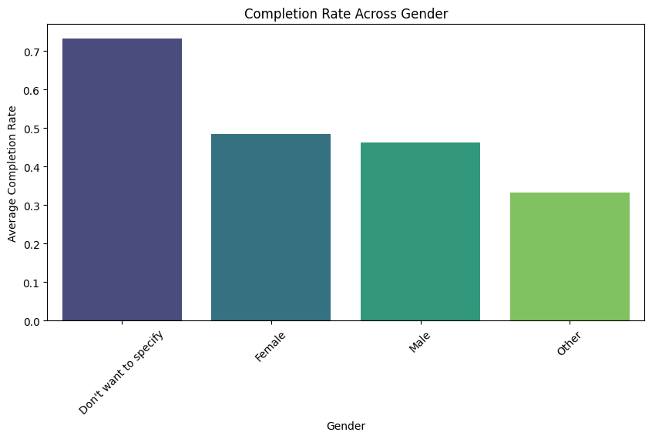

### 

### **Key Observations & Trends:**

**1. Highest Completion Rate Among Participants Who Chose Not to Specify Their Gender (73.3%)**

* Participants who **did not disclose their gender** show the **highest completion rate**.
* **Possible reasons:**
  + Highly **motivated individuals who carefully select their opportunities**.
  + More **selective in choosing programs that align with their goals**.

**2. Female Participants Have a Higher Completion Rate Than Males**

* **Completion rate:** **Females (48.5%) vs. Males (46.2%)**.
* **Possible reasons:**
  + **Higher engagement and commitment** among female learners.
  + Better **alignment between available opportunities and female career interests**.

**3. Males Show Slightly Lower Completion Rates**

* **Males (46.2%)** have a **slightly higher drop-off rate than females**.
* **Possible influencing factors:**
  + **Competing priorities** such as workload or other commitments.
  + Differences in **career expectations or program alignment issues**.

**4. Lowest Completion Rate Among "Other" Gender Category (33.3%)**

* Participants who **identify as "Other" have the lowest completion rate**.
* **Possible reasons:**
  + **Barriers to engagement**, accessibility challenges, or lack of relevant opportunities.
  + **Limited visibility** of programs tailored to their needs.
  + **Further investigation required** to understand and address these challenges.

### **Key Takeaways & Recommendations:**

**1. Enhance Inclusivity & Support for Underrepresented Groups**

* Participants **identifying as "Other" have the lowest completion rate**.
* Introduce **mentorship programs, networking opportunities, and tailored support** to improve retention.

**2. Leverage High Engagement of Female Participants**

* Design opportunities that **align with female career interests** to further **boost participation and retention**.
* Provide **scholarships, leadership roles, and mentorship programs** to encourage continued engagement.

**3. Investigate Male Drop-Offs to Improve Retention**

* Analyze **reasons for male disengagement** through **surveys or feedback collection**.
* Implement **engagement strategies focused on male learners’ interests and career pathways**.

**4. Personalized Support for Non-Disclosing Participants**

* **High completion rates** indicate strong motivation—**understanding their preferences can help optimize program offerings**.
* Provide **anonymous feedback options** to gain insights into their learning experiences.

## **Demographics: Age Group-wise Signups & Drop-off Rate**

*This analysis highlights how different age groups engage with opportunities, showing both signup trends and drop-off rates. It helps identify where engagement is strong and where improvements are needed.*

### **Extracted Charts:**

🔹 **Signups by Age Group**🔹 **Drop-off Rate by Age Group**

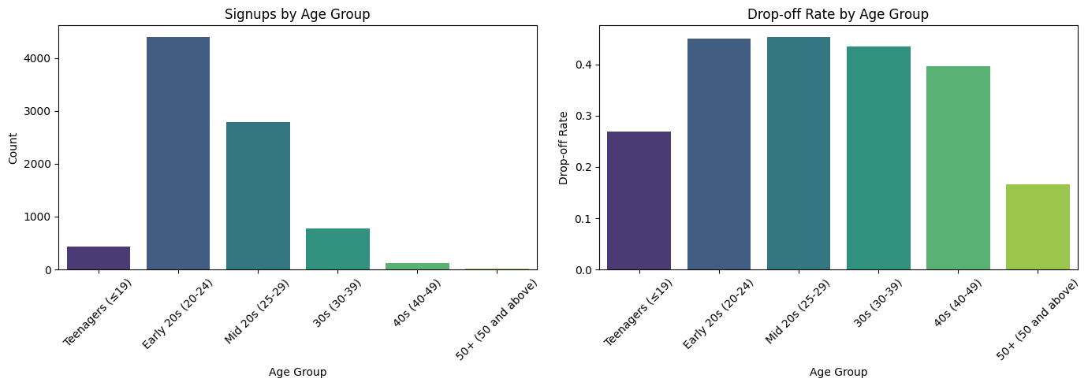

### 

### 

### **Key Insights:**

**1. Young Adults (20-29) Drive the Majority of Signups but Have the Highest Drop-Off Rates**

* **Early 20s (20-24) and Mid 20s (25-29) account for 7,189 signups**, making them the **largest age group**.
* However, their **drop-off rates are also the highest (~45%)**, indicating **engagement challenges**.
* **Possible reasons for drop-offs:**
  + **Competing priorities** such as university studies, job searching, or work commitments.
  + **Mismatch between program expectations and learner goals**.
  + **Lack of structured support** during the opportunity.

**2. 30s Show Strong Engagement Despite Lower Signups**

* **780 signups from participants aged 30-39**, with a **slightly lower drop-off rate (43.5%)** than younger groups.
* **Possible reasons for better retention:**
  + More **career-focused decision-making**, leading to **selective applications**.
  + **Greater commitment to professional growth** compared to younger participants.

**3. Teenagers (≤19) Have the Best Retention Among Younger Participants**

* **439 signups from teenagers**, with a relatively **low drop-off rate of 26.9%**.
* **Why is retention higher?**
  + **Higher motivation** to gain early career experience.
  + **Fewer competing responsibilities**, allowing them to stay engaged longer.

**4. Drop-Off Rates Decline with Age**

* Participants in their **40s (40-49) have a 39.7% drop-off rate**, showing slightly **better retention than younger groups**.
* **50+ participants have the lowest drop-off rate (16.7%)**, though they also have the **fewest signups (12 total)**.
* **Older participants likely enroll with clear goals and stronger commitment**, reducing their likelihood of dropping out.

### **Key Takeaways & Recommendations:**

**1. Improve Retention for Young Adults (20-29) Through Better Engagement Strategies**

* Introduce **mentorship programs, networking opportunities, and flexible timelines** to keep them engaged.
* Offer **structured support, reminders, and progress tracking** to help them complete their opportunities.
* Align **program expectations with learner goals** to **reduce mismatches**.

**2. Leverage High Retention Among Teenagers and Older Participants (40+)**

* **Teenagers are highly motivated**—expand opportunities targeted at them, such as **internships, skill-building programs, and career exploration initiatives**.
* **Older participants (40+) show strong commitment**—offer **advanced professional development programs** to engage them further.

**3. Optimize Programs for Participants in Their 30s**

* Provide **career-aligned incentives and upskilling opportunities** to sustain participation.
* Implement **certifications or leadership pathways** to encourage engagement.

**4. Customize Engagement Strategies Based on Age Group**

* Use **personalized communication and adaptive learning strategies** to cater to different needs.
* Encourage **peer networking and age-specific support groups** to boost motivation.

## **Demographics: Gender-wise Signups & Drop-off Rate**

*This analysis examines how different gender groups engage with opportunities, highlighting variations in signup numbers and drop-off rates. It provides insights into gender-specific engagement trends and strategies for improving retention.*

### 

### **Extracted Charts:**

🔹 **Signups by Gender**🔹 **Drop-off Rate by Gender**

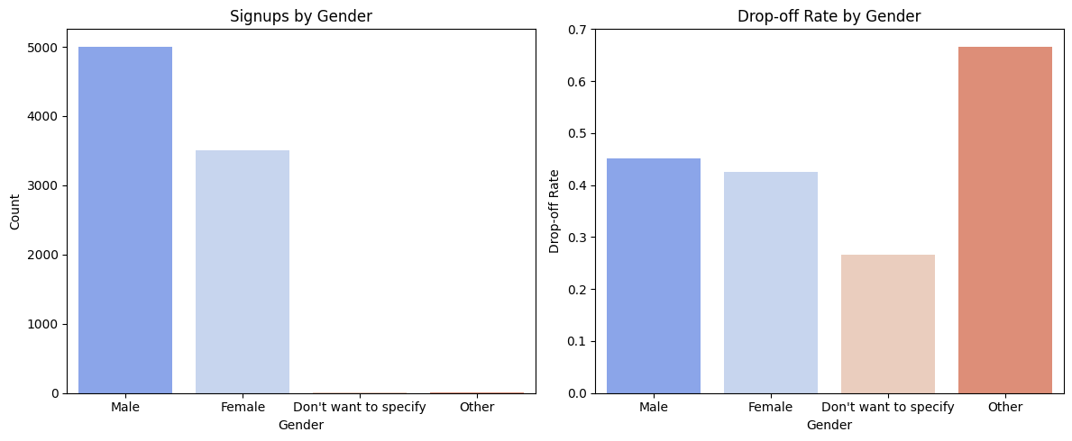

### 

### **Key Insights:**

**1. Male Participants Form the Largest Group but Have the Highest Drop-Off Rate**

* **Males account for 5,006 signups**, making them the **largest demographic**.
* However, they also have a **drop-off rate of 45.0%**, the **second-highest** among all gender categories.
* **Possible reasons for high drop-offs:**
  + Lack of **personalized guidance or structured engagement mechanisms**.
  + **Competing priorities**, such as **academic workload or job-seeking efforts**.

**2. Female Participants Show Better Retention**

* **3,512 signups**, making females the **second-largest group**.
* Their **drop-off rate is lower (42.5%) than males**, indicating **better engagement and program completion**.
* **Possible reasons for stronger retention:**
  + **Better alignment between program structures and female career goals**.
  + **Higher participation in structured learning programs** with built-in support systems.

**3. Non-Binary Participants ("Other") Face the Highest Drop-Off Rate**

* Though only **3 signups were recorded**, the **drop-off rate is 66.7%**, the **highest among all gender groups**.
* **Possible reasons for high drop-offs:**
  + **Lack of inclusivity or tailored engagement strategies**.
  + **Potential accessibility or community support gaps**.

**4. Participants Who Prefer Not to Specify Gender Show the Lowest Drop-Off Rate**

* **15 participants selected "Don't want to specify,"** with a **drop-off rate of just 26.7%**, the **lowest among all groups**.
* **Possible reasons for higher retention:**
  + **Highly selective and intentional participants** who carefully choose relevant opportunities.
  + **A smaller but highly committed group** with **self-driven motivation**.

### **Key Takeaways & Recommendations:**

**1. Improve Retention for Male Participants**

* Introduce **personalized support and milestone-based engagement strategies** to sustain interest.
* Provide **career guidance and mentorship programs** to help them stay engaged.

**2. Enhance Support for Non-Binary Participants**

* Improve **inclusivity efforts** by creating **safe spaces, mentorship programs, and tailored communication**.
* Ensure **better representation and accessibility** for diverse gender identities in learning opportunities.

**3. Leverage Stronger Retention Among Female Participants**

* Expand **female-targeted initiatives** to encourage **further participation and career growth**.
* Offer **networking opportunities, leadership programs, and flexible pathways** to maintain engagement.

**4. Investigate Anonymous Participants' Needs**

* Conduct **surveys** to understand **why participants who don’t specify gender have higher retention**.
* Apply **best practices from this group** to other demographics for **better engagement**.

**5. Customize Engagement Strategies by Gender**

* Tailor engagement strategies based on **different groups' preferences** to reduce drop-offs.
* Provide **mentorship, peer support, and structured incentives** to improve **long-term participation** across all gender identities.

## **Top & Bottom 5 Countries Based on Signups, Completion, and Drop-off Rates**

## *This analysis highlights the top and bottom 5 countries based on signups, completion rates, and drop-off rates. It helps identify geographic trends in engagement and retention.*

### 

### **Extracted Charts:**

🔹 **Top 5 Countries: Signups, Completion, and Drop-off Rates**🔹 **Bottom 5 Countries: Signups, Completion, and Drop-off Rates**

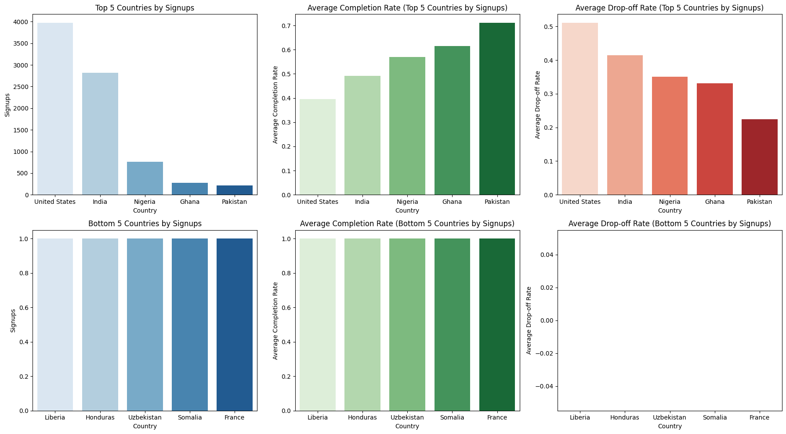

### 

### **Key Insights:**

### **1. United States Leads in Signups but Has a High Drop-Off Rate**

* **3,974 signups**, the **highest among all countries**.
* However, the **completion rate is low (39.51%)**, and the **drop-off rate is high (51.08%)**.
* **Possible reasons for high drop-offs:**
  + **High availability of similar opportunities**, leading to disengagement.
  + **Competing commitments** such as academics, jobs, or internships.

**2. Pakistan Has the Highest Completion Rate Among the Top 5 Countries**

* **218 signups** with a **completion rate of 71.10%**, the **highest among the top 5 countries**.
* The **drop-off rate is only 22.48%**, indicating **strong engagement and commitment**.

**3. Ghana and Nigeria Show Strong Completion Trends**

* **Ghana: 61.45% completion rate, 33.09% drop-off rate**.
* **Nigeria: 56.97% completion rate, 35.00% drop-off rate**.
* **Possible reasons for strong completion rates:**
  + Learners in these regions may **find unique value in the opportunities**.
  + **High motivation to complete programs** for **career advancement**.

**4. Small-Sample Countries Have 100% Completion Rates**

* Countries with only **1 signup each (e.g., Liberia, France, Honduras) show perfect completion (100%) and 0% drop-offs**.
* **Why?**
  + **Small sample size makes it difficult to determine actual trends**.
  + These cases should be treated as **outliers rather than performance benchmarks**.

### **Key Takeaways & Recommendations:**

**1. Improve Retention in High-Drop-Off Countries (e.g., U.S.)**

* Provide **structured support, milestone rewards, and progress tracking** to keep learners engaged.
* Investigate **why learners disengage**—**survey responses** could provide insights into **unmet needs**.

**2. Expand Outreach in High-Completion Regions (e.g., Pakistan, Ghana, Nigeria)**

* Scale **marketing efforts** in these countries to **leverage strong engagement**.
* Develop **region-specific learning content and localized engagement strategies**.

**3. Consider Small-Sample Countries for Future Growth**

* While **100% completion is promising**, increase signups in these regions to get **more meaningful insights**.
* Test **engagement strategies** in these countries to see if completion remains high with **larger participant pools**.

**4. Develop Country-Specific Retention Strategies**

* Use **localized success stories, mentorship programs, and community-building initiatives** to drive engagement.
* Implement **flexible learning options** to accommodate **regional differences in internet access, education levels, and career goals**.

## **Demographics: Top & Bottom 5 Institutions Based on Signups, Completion, and Drop-off Rates**

*This analysis highlights the top and bottom 5 institutions based on signups, completion rates, and drop-off rates. It helps identify institutional trends in engagement and retention.*

### 

### **Extracted Charts:**

🔹 **Top 5 Institutions: Signups, Completion, and Drop-off Rates**🔹 **Bottom 5 Institutions: Signups, Completion, and Drop-off Rates**

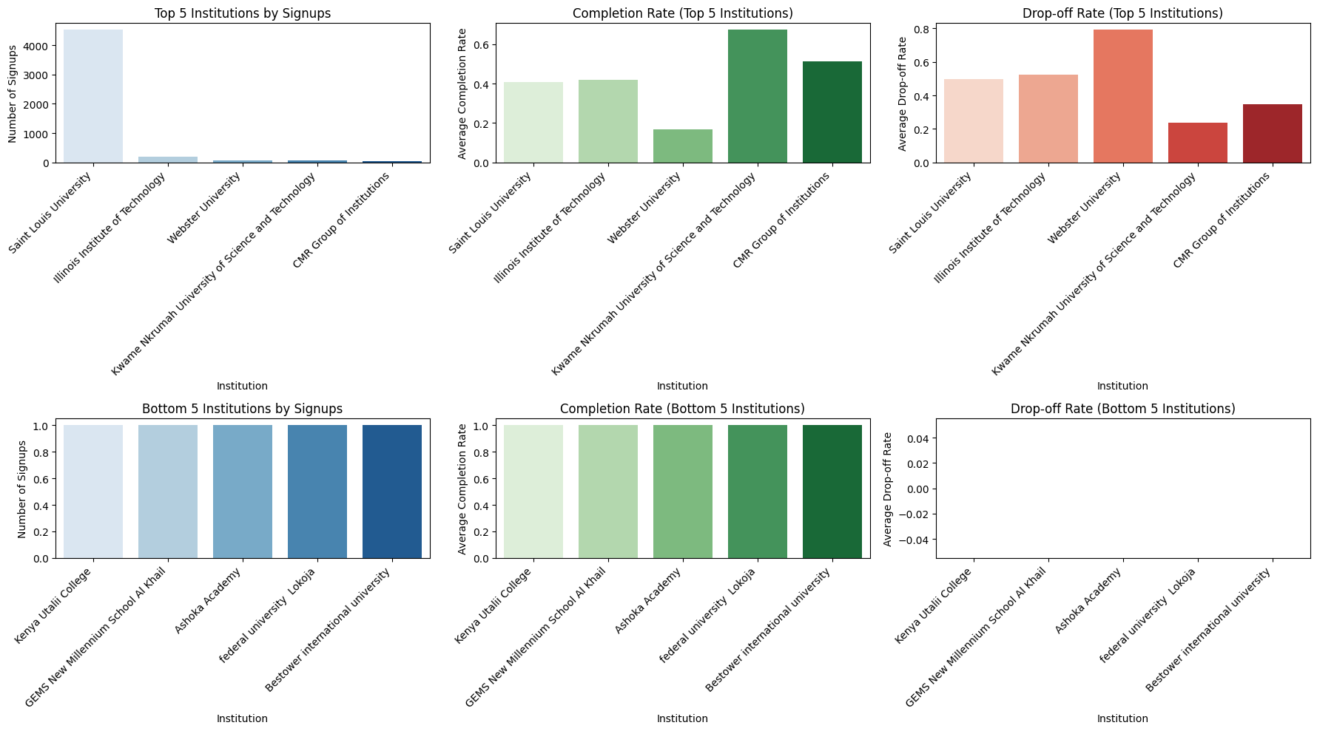

### 

### **Key Insights:**

**1. Saint Louis University Leads in Signups but Struggles with Drop-Offs**

* **4,522 signups**, making it the **most active institution** in the dataset.
* However, the **completion rate is moderate (40.8%)**, and the **drop-off rate is high (49.8%)**, indicating **retention challenges**.
* **Possible reasons for high drop-offs:**
  + **High volume of signups** may lead to **less personalized support**.
  + Students might be **exploring multiple opportunities** but **not fully committing**.

**2. Kwame Nkrumah University of Science and Technology Shows the Best Retention**

* **55 signups**, but with the **highest completion rate (67.3%)** and **lowest drop-off rate (23.6%)** among the top institutions.
* **Possible reasons for strong retention:**
  + The institution may have **strong academic support systems** that help students complete their programs.
  + Learners may have a **better alignment between expectations and program structure**.

**3. Webster University Struggles with Engagement**

* **72 signups**, but with a **low completion rate (16.7%)** and a **very high drop-off rate (79.2%)**.
* **Possible reasons for low engagement:**
  + **Lack of structured mentorship or support mechanisms**.
  + **Programs may not align well with student expectations** or schedules.

**4. Small-Sample Institutions Show 100% Completion**

* **Bottom 5 institutions (Kenya Utalii College, GEMS New Millennium School Al Khail, Ashoka Academy, Federal University Lokoja, and Bestower International University) recorded just 1 signup each**.
* All had **100% completion and 0% drop-off rates**, but the **sample size is too small to draw strong conclusions**.

### **Key Takeaways & Recommendations:**

**1. Improve Retention in High-Drop-Off Institutions (e.g., Saint Louis University, Webster University)**

* Provide **structured mentorship, progress tracking, and milestone-based incentives** to keep learners engaged.
* **Survey students** to understand **why disengagement happens** and how to address it.

**2. Leverage High-Retention Institutions as Models (e.g., Kwame Nkrumah University of Science and Technology)**

* Identify **successful engagement practices at this institution** and apply them to others.
* Promote **peer-to-peer mentorship and structured engagement programs** for better retention.

**3. Expand Opportunities for Smaller Institutions with Strong Engagement**

* The **100% completion rate in bottom institutions suggests** that **those who sign up are highly committed**.
* Increase **outreach efforts in these institutions** to attract more signups while maintaining strong retention.

**4. Develop Institution-Specific Retention Strategies**

* Use **targeted engagement plans based on historical completion trends** for each institution.
* Partner with **academic advisors or faculty members** to offer students **better guidance and support**.

## **Top & Bottom 5 Majors Based on Signups, Completion, and Drop-off Rates**

*This analysis highlights the top and bottom 5 academic majors based on signups, completion rates, and drop-off rates. It provides insights into which fields of study attract the most learners and where retention challenges exist.*

### 

### **Extracted Charts:**

🔹 **Top 5 Majors: Signups, Completion, and Drop-off Rates**🔹 **Bottom 5 Majors: Signups, Completion, and Drop-off Rates**

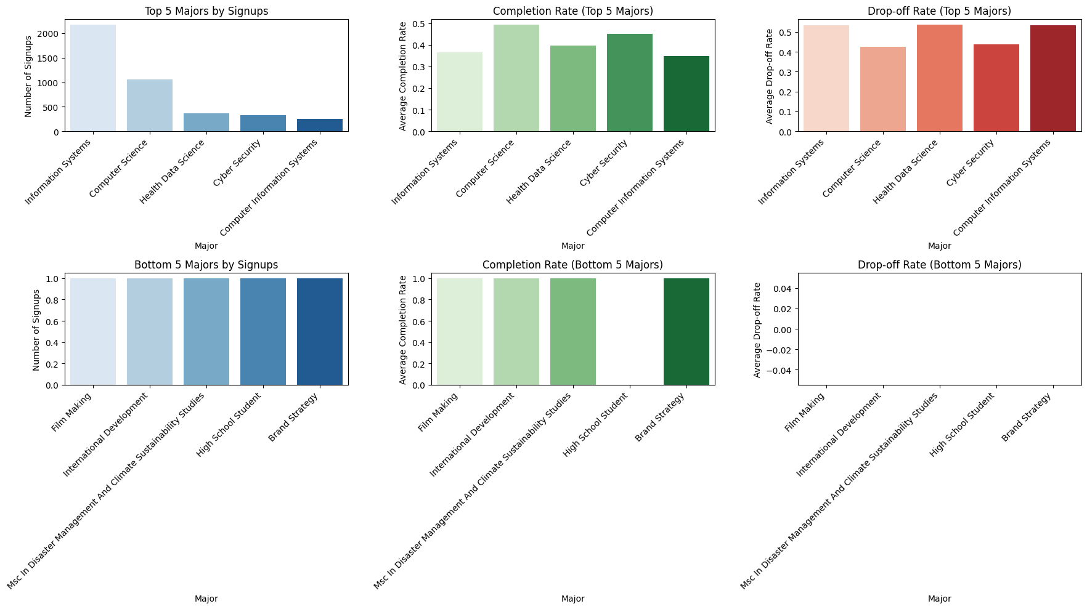

### 

### **Key Insights:**

**1. Information Systems Leads in Signups but Faces High Drop-Offs**

* **2,176 signups**, making it the **most popular major**.
* However, the **completion rate is low (36.4%)**, and the **drop-off rate is high (53.4%)**, indicating **challenges in sustaining engagement**.
* **Possible reasons for high drop-offs:**
  + **Workload challenges or course difficulty**.
  + **Lack of direct career incentives** or structured support.

**2. Computer Science Shows Better Retention Compared to Other Tech Majors**

* **1,051 signups**, with a **higher completion rate (49.3%)** and a **lower drop-off rate (42.3%)** than Information Systems.
* This suggests that **structured learning programs in Computer Science** may be **more engaging or well-supported**.

**3. Health Data Science and Cyber Security Have Moderate Retention Rates**

* **Health Data Science:** **371 signups**, but a **low completion rate (39.6%)** and a **high drop-off rate (53.6%)**.
* **Cyber Security:** **326 signups**, with a **moderate completion rate (45.1%)** and a **drop-off rate of 43.9%**.
* These fields may require **better mentorship and career-focused incentives** to sustain engagement.

**4. Computer Information Systems Has the Lowest Completion Rate Among Top Majors**

* **250 signups**, but a **low completion rate (34.8%)** and a **high drop-off rate (53.2%)**.
* **Possible reasons:**
  + **Lack of industry alignment in learning content**.
  + **Participants may switch to other tech-related programs** due to overlapping skills.

**5. Bottom 5 Majors Show Small but Highly Committed Participation**

* **Film Making, International Development, MSc in Disaster Management and Climate Sustainability, and Brand Strategy all had only 1 signup each**.
* **All achieved a 100% completion rate with 0% drop-off**.
* **High School Student had 1 signup but a 0% completion rate**, suggesting **immediate disengagement**.

### **Key Takeaways & Recommendations:**

**1. Improve Retention in High-Drop-Off Majors (e.g., Information Systems, Health Data Science, Computer Information Systems)**

* Provide **structured onboarding, mentorship programs, and industry-aligned certifications** to keep learners engaged.
* Introduce **interactive learning components (projects, real-world case studies)** to increase engagement.

**2. Leverage Stronger Retention in Computer Science and Cyber Security**

* Study **what makes Computer Science retain students better** and apply those strategies to similar fields.
* Offer **career pathway guidance and internship opportunities** to improve completion rates in tech-related majors.

**3. Expand Outreach in Small but Committed Majors**

* The **100% completion rate in niche majors suggests strong dedication** among students.
* Increase **program visibility for these fields** to attract more signups while maintaining high engagement.

**4. Develop Major-Specific Engagement Strategies**

* Use **career-oriented learning paths tailored for each major** to align student expectations.
* Offer **skill-based competitions, networking events, and industry mentorship** to improve retention.

# ***Outliers and Anomalies Analysis:***

## **Completion Time Outliers: Drop-off Rate vs. Opportunity Duration**

*This analysis examines how drop-off rates vary across different opportunity durations, identifying critical periods where learners disengage. The insights help in designing better retention strategies.*

### 

### **Extracted Charts:**

**Drop-off Rate vs. Opportunity Duration**

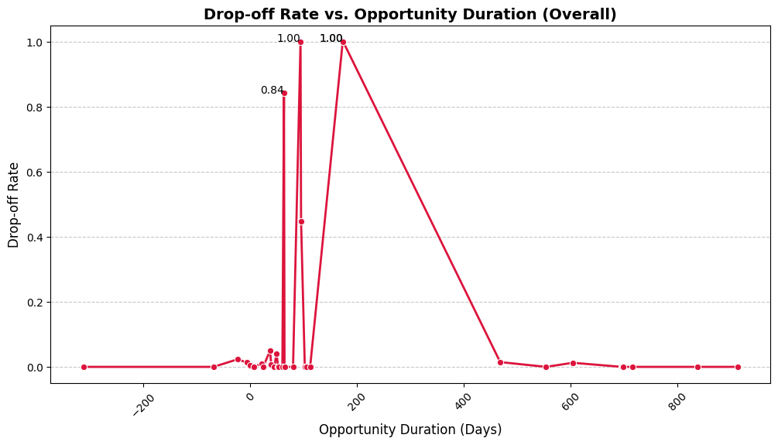

### 

### **Key Insights:**

**1. Short-Term Opportunities (Less than 60 Days) Show Low Drop-Off Rates**

* Most short-term opportunities **(under 60 days)** have **drop-off rates below 5%**, meaning learners tend to complete them.
* **Lowest drop-off rates occur around 6-7 days (0%)**, indicating that **very short-term programs maintain engagement well**.
* However, **spikes occur at day 37 (5%) and day 49 (4.18%)**, which may indicate **critical disengagement points**.

**2. Mid-Term Opportunities (60 to 100 Days) Experience High Drop-Offs**

* **A major drop-off spike happens at 63 days (84.2%)**, meaning many learners disengage around **two months into the opportunity**.
* Another **sharp increase occurs at 94 days (100% drop-off rate)**, indicating that participants struggle to stay engaged in **three-month-long programs**.

**3. Long-Term Opportunities (More than 100 Days) Show Mixed Trends**

* At **173 and 174 days, drop-off rates reach 100%**, showing that **half-year-long opportunities struggle with retention**.
* However, beyond **468 days, drop-off rates drop to 1-2%**, indicating that **highly committed learners persist in long-duration programs**.

**4. General Trends Indicate Critical Disengagement Periods**

* Drop-off rates **significantly increase between 60-100 days**, suggesting that **this is a critical intervention period**.
* **Short-term (≤1 week) and long-term (>6 months) programs show low drop-off rates**, meaning they either **complete quickly** or **attract highly dedicated participants**.

### **Actionable Recommendations:**

**1. Optimize Mid-Term Opportunities (60-100 Days) to Reduce Drop-Offs**

* Introduce **structured progress tracking and milestone rewards** to maintain engagement.
* Implement **check-ins or mentorship programs around the 60-day and 90-day marks** to provide additional support.
* Reassess **content structure and workload** to prevent disengagement.

**2. Identify and Address Critical Drop-Off Points**

* Conduct **surveys or interviews** with learners who drop out at **63, 94, and 173 days** to understand their challenges.
* Improve **opportunity flexibility, pacing, and engagement strategies** for these durations.

**3. Promote Short-Term Programs with Proven High Retention**

* Expand **6-7 day programs** with **structured, interactive learning experiences**.
* Encourage **learners who complete short-term opportunities** to transition into longer programs with built-in engagement mechanisms.

**4. Improve Long-Term Program Retention Beyond 6 Months**

* **Participants beyond 468 days are highly committed**—enhance their experience with **advanced-level projects, certifications, or leadership roles**.
* Offer **extended mentorship, networking opportunities, and career benefits** to retain them.

## **Completion Time Outliers: Drop-off Rate vs. Opportunity Duration with Opportunity Category**

*This analysis examines how drop-off rates vary across different opportunity categories and durations, highlighting category-specific retention trends.*

### 

### **Extracted Charts:**

**Drop-off Rate vs. Opportunity Duration by Category**

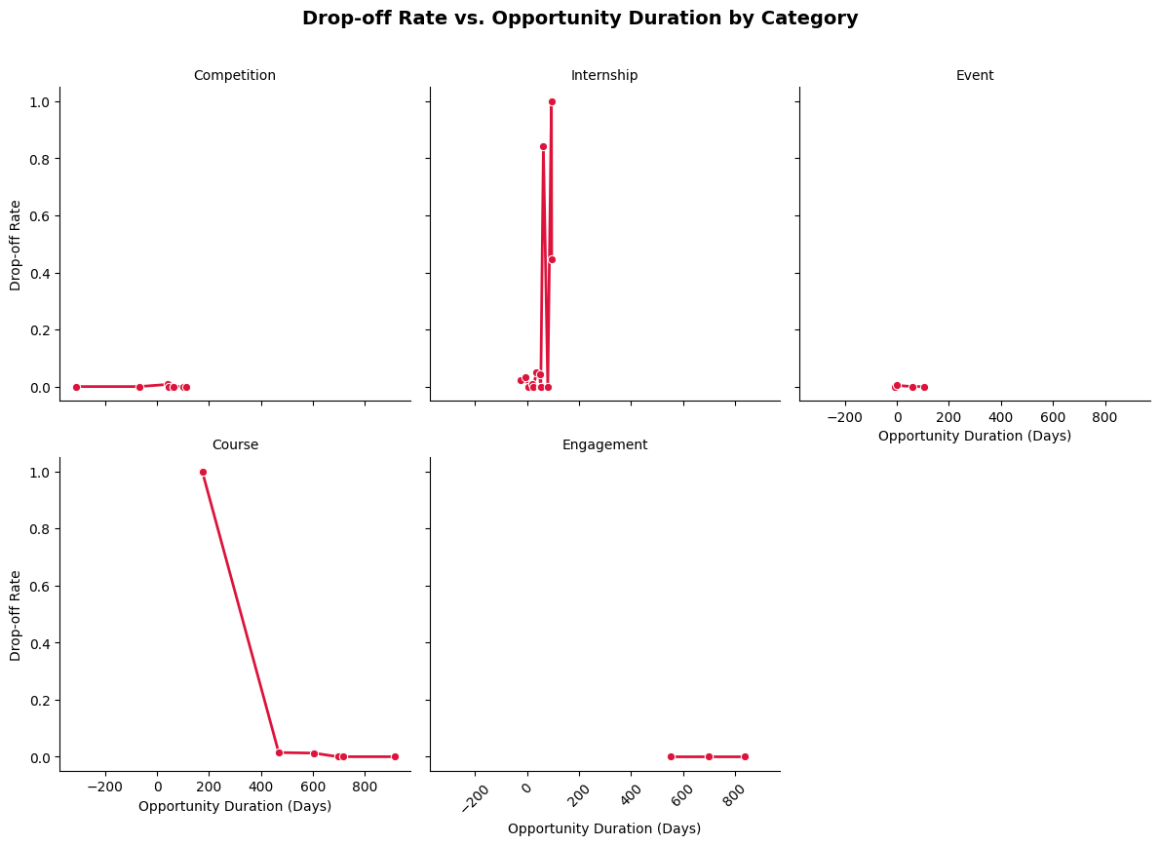

### 

### 

### **Key Insights:**

**1. Short-Term Opportunities (Less than 60 Days) Show High Retention**

* **Competitions and Events have near 0% drop-off rates**, indicating **strong engagement in short-duration programs**.
* **Internships** show moderate drop-off rates, with **spikes at:**
  + **Day 37 (5%)**
  + **Day 49 (4.18%)**
* A **sharp spike at 63 days (84.2%)** suggests **this is a critical disengagement period for internships**.

**2. Mid-Term Opportunities (60 to 100 Days) Face Severe Drop-Offs**

* **Internships at 94-95 days experience drop-offs of 100% and 44.8%**, suggesting that **three-month internship durations may be a key disengagement point**.
* **Courses at 173-174 days have a 100% drop-off rate**, implying that **half-year-long courses may struggle to retain learners**.

**3. Long-Term Opportunities (More than 100 Days) Show Mixed Retention Trends**

* **Courses beyond 173 days exhibit extreme behaviors:**
  + **100% drop-off at 173-174 days**
  + **1-2% drop-off at 468-604 days**
  + **0% drop-off beyond 696 days**, meaning **highly committed learners persist in long-term courses**.
* **Engagement activities beyond 500 days maintain 0% drop-offs**, indicating that **mentorship and networking programs retain participants well**.

**4. Category-Specific Trends Reveal Drop-Off Hotspots**

* **Competitions and Events maintain high retention**, making them strong engagement tools.
* **Internships suffer major disengagement between 63-95 days**, requiring intervention at this stage.
* **Courses show extreme drop-off variations**, either **completely losing learners at 173 days** or **retaining them fully beyond 600 days**.
* **Engagement activities (e.g., workshops, mentoring) consistently retain learners over time**, suggesting **strong learner commitment**.

**5. General Observations Indicate Key Engagement Periods**

* **Drop-off rates increase significantly between 60-100 days**, making this a **critical intervention window**.
* **Short-term (≤1 month) and long-term (>6 months) opportunities tend to fully retain participants or lose very few**.
* **Targeted strategies for mid-term opportunities (63-100 days) could significantly reduce drop-offs**.

### **Actionable Recommendations:**

**1. Address Internship Drop-Offs Around 63-95 Days**

* Introduce **midway check-ins and structured progress tracking** to keep learners engaged.
* Offer **mentorship and networking opportunities at the 60-day mark** to encourage continued participation.
* Provide **early expectation setting** to minimize mismatches between learner goals and internship structure.

**2. Reduce Drop-Offs for Half-Year Courses (173-174 Days)**

* Implement **modular course structures with milestone certifications** at **3-month intervals** to sustain engagement.
* Introduce **gamification and interactive elements** to retain learners.

**3. Promote Engagement-Based Learning Models for Long-Term Retention**

* Expand **mentorship, networking, and interactive opportunities**, as they show **0% drop-off beyond 500 days**.
* Encourage **learners in shorter opportunities to transition into long-term structured programs** with built-in engagement features.

**4. Develop Category-Specific Retention Strategies**

* **Competitions & Events:** Maintain strong engagement by leveraging them as **onboarding tools for longer programs**.
* **Internships:** Improve **mentor involvement and skill tracking** to reduce disengagement.
* **Courses:** Offer **personalized learning pathways and peer interactions** to enhance motivation.

# **Low Completion Days: Drop-off Rate by Opportunity Type**

*This analysis examines drop-off rates across different opportunity categories, highlighting which programs struggle with retention and where learners are most likely to disengage. Understanding these trends helps in designing better engagement strategies to improve completion rates.*

### 

### **Extracted Charts:**

**Drop-off Rate by Opportunity Category**

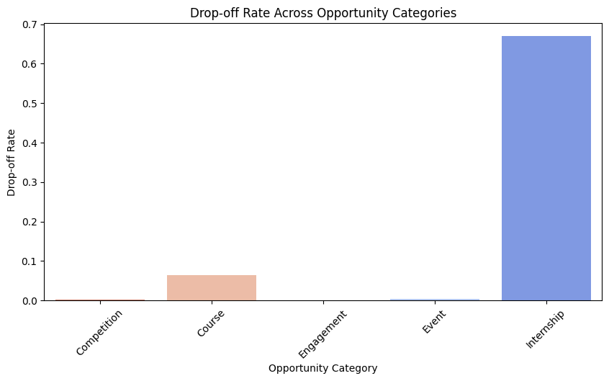

## 

## **Key Insights:**

**1. Internships Have the Highest Drop-Off Rate (66.9%)**

* A majority of learners struggle to complete internships, leading to **high disengagement**.
* **Possible reasons for drop-offs:**
  + **Long duration** making it difficult for learners to stay committed.
  + **Heavy workload** leading to burnout.
  + **Mismatch between expectations and reality**, causing learners to drop out.
* **Solution:** Conducting a deeper analysis into **internship experiences and learner expectations** can help improve retention.

**2. Courses Have a Moderate Drop-Off Rate (6.4%)**

* While **most learners complete courses**, a **small percentage disengage before finishing**.
* **Possible reasons for drop-offs:**
  + **Lack of engagement**, leading to boredom.
  + **Difficulty level**, causing frustration.
  + **Competing priorities**, reducing learner focus.
* **Solution:** Improving **course flexibility, content quality, and support systems** can help boost completion rates.

**3. Competitions (0.2%) and Events (0.4%) Have Very Low Drop-Off Rates**

* **Competitions and events require minimal long-term commitment**, making them **easier to complete**.
* **Learners are highly motivated** to finish these short-term opportunities, unlike longer-term programs such as internships or courses.

**4. Engagement-Based Opportunities Have a 0% Drop-Off Rate**

* **Engagement activities retain 100% of learners**, meaning participants stay committed throughout the program.
* This suggests that **interactive and community-driven opportunities align well with learners' interests and availability**.

## **Actionable Recommendations:**

## **1. Improve Internship Retention by Addressing Drop-Off Factors**

## **Introduce structured check-in sessions** to maintain engagement and provide ongoing support.

## **Offer additional support resources** such as **mentorship, progress tracking, and structured guidance** to enhance learner experience.

## **Enhance the internship matching process** to ensure **better alignment between learners and available opportunities**.

## 

## **2. Enhance Course Completion Rates**

## **Implement gamification & rewards** (badges, certificates) to **boost motivation and engagement**.

## **Personalize learning** through **adaptive content paths** based on user performance and progress.

## **Use automated reminders and progress tracking** to keep learners **accountable and engaged throughout the course**.

**3. Leverage High-Retention Opportunity Types (Competitions & Engagement-Based Activities)**

* **Encourage more signups** for **competitions and engagement-based activities**, as they show **high completion rates**.
* **Apply engagement-based strategies** (e.g., community learning, networking events, peer collaboration) **to other opportunity types** to increase overall retention.

# ***Recommendations:***

## **Target Peak Days: Optimizing Marketing Strategies for Peak Signup Periods**

*Analysis shows that signups peak in* ***January and August****, while engagement drops in* ***March-April****. To maximize signups and engagement, targeted marketing strategies should be aligned with these trends.*

### 

### **Recommended Strategies:**

**1. Launch High-Impact Campaigns Around Peak Months**

* **January & August:**
* **Promote major learning opportunities** such as **internships, courses, and competitions** before and during peak periods.
* **Offer exclusive early-bird incentives** to encourage signups.
* **Leverage social media trends & email marketing** to increase visibility.

**2. Utilize Data-Driven Outreach for Better Conversions**

* **Segment and retarget high-intent users** who previously browsed opportunities but didn’t sign up.
* **Use predictive analytics to identify likely participants** and engage them before peak months.

**3. Maximize Signups Through Referral & Ambassador Programs**

* Introduce **peer referral incentives** to encourage word-of-mouth engagement.
* Partner with **universities, career advisors, and online communities** to promote opportunities effectively.

## **Investigate Drops: Addressing Declines in Signups & Completions**

*March-April and mid-duration opportunities (60-100 days) show high drop-offs. This suggests that engagement fatigue and competing priorities may be key factors.*

### 

### **Recommended Strategies:**

**1. Conduct Drop-Off Surveys & Engagement Analytics**

* **Gather feedback from users who dropped out** to understand their reasons.
* **Analyze engagement data** to identify patterns in disengagement and take corrective actions.

**2. Improve Mid-Program Engagement with Structured Checkpoints**

* Implement **progress tracking, milestone-based incentives, and personalized interventions** to keep learners engaged.
* Introduce **community-driven support systems**, including discussion forums and peer networking.

**3. Implement Timely Re-Engagement Campaigns**

* **Automated email and SMS reminders** for users who haven’t engaged within a set period.
* **Adaptive re-engagement content** (e.g., personalized video messages or incentives) to bring back disengaged users.

## **Support Long-Tail Users: Resources for Users with Longer Completion Times**

*Learners in long-duration programs (>100 days) require sustained engagement and structured support to prevent drop-offs.*

### 

### **Recommended Strategies:**

**A. Introduce Modular Learning Paths** 1. Break down **long-term courses into shorter, milestone-based achievements**.  
 2. Offer **certifications at key completion stages** to encourage continued progress.

**B. Provide Mentorship & Community Engagement** 1. **Pair learners with mentors** or study groups to maintain motivation.  
 2. Offer **quarterly networking events, live Q&A sessions, and interactive discussions**.

**C. Optimize Flexibility & Personalized Learning Paths** 1. **Self-paced learning options** allow users to balance commitments while progressing steadily.  
 2. **AI-driven recommendations for course adjustments** based on user engagement trends.

## 

## **Segment Strategies: Tailored Approaches for Different Demographic Groups**

*Completion rates and engagement patterns vary across different user demographics. Personalized strategies can enhance retention and satisfaction.*

### 

### **Recommended Strategies:**

**1. Support for Young Adults (20-29) & Working Professionals**

* Offer **flexible learning schedules, mobile-first content, and on-demand webinars**.
* Introduce **micro-courses & short-term certifications** to accommodate busy schedules.

**2. Enhance Engagement for Female Participants**

* **Leverage mentorship programs** with industry professionals.
* **Highlight career-aligned opportunities** in outreach campaigns.

**3. Improve Retention for Older Learners (40+)**

* Offer **leadership training, career transition resources, and industry networking**.
* Design **structured upskilling tracks** for mid-career professionals.

**4. Inclusive Engagement for Non-Binary & Undisclosed Gender Participants**

* Ensure **representation in marketing, testimonials, and mentorship programs**.
* Conduct **research on inclusivity barriers** to improve support systems.

# 

# ***Conclusion***

## **Key Insights: Summary of Findings**

*This study identified key trends, challenges, and opportunities for improving learner engagement and retention across different opportunity types.*

1. **Internships attract the highest signups but also have the highest drop-off rate (66.9%)**, requiring structured support mechanisms.
2. **Short-term opportunities (competitions, events) have the highest completion rates**, highlighting their effectiveness in driving engagement.
3. **Long-term engagement programs (mentorships, networking) show excellent retention**, proving the value of interactive learning.
4. **Completion rates vary significantly across demographics**, emphasizing the need for personalized engagement strategies.
5. **Drop-offs peak between 60-100 days**, making this a **critical period for intervention through milestone rewards and mentorship**.

## 

## **Next Steps: Proposed Action Plan**

**1. Implement Data-Driven Retention Strategies**

* Track **real-time engagement metrics** to predict drop-offs and trigger re-engagement actions.
* Develop **automated intervention tools** to support struggling learners.

**2. Enhance Personalization in Learning Paths**

* Create **adaptive, modular courses** that adjust based on **learner engagement and performance**.
* Introduce **micro-certifications** for milestone completions.

**3. Expand Outreach & Engagement for High-Retention Opportunities**

* Use **competitions and events as onboarding tools** to increase engagement.
* Scale **successful mentorship & community-driven programs** for long-term retention.

**4. Conduct Predictive Modeling & Churn Analysis** *(Upcoming Focus: Next Week)* *Next week, we will focus on predictive modeling to anticipate learner drop-offs and churn behavior. This will help in proactively implementing retention strategies.*

* **Churn Prediction Model:** Identify key risk factors for disengagement and optimize interventions.
* **Machine Learning for Completion Rates:** Use historical data to predict which users are most likely to complete or drop off.
* **Behavioral Segmentation:** Cluster users based on engagement patterns and personalize re-engagement efforts.

**5. Investigate High Drop-Off Points & Further Optimize Engagement Tactics**

* **Analyze the causes behind major disengagement points** (e.g., 63 days, 94 days, 173 days).
* **Refine marketing, content, and engagement strategies** based on predictive insights.

### **Final Thoughts**

By incorporating **Predictive Modeling & Churn Analysis**, we can **proactively address user disengagement**, refine our **personalization strategies**, and **significantly improve retention rates**. The integration of **data-driven insights with machine learning techniques** will provide **scalable solutions for long-term engagement optimization**.